# Appendix

This appendix includes supporting documentation and analysis for the endogenous group selection model of sustainable resource use institutions. This includes model a robustness test of initial conditions, additional results, an extensive sensitivity analysis, and documentation in ODD format. The model is available at [openabm.org/model/4627](https://www.openabm.org/model/4627/).

# Robustness Test

We also tested an alternative initialization condition. In the standard initialization procedure each of the nine groups is composed of twelve identical individuals all of whom are assigned one of the nine possible trait combinations. This condition creates strong initial between-group selection because groups are perfectly correlated with trait differences. The alternative condition is identical except that individuals are randomly mixed between groups, so that group markers were not correlated with traits. As expected, reducing initial correlation between traits and groups reduced group selection and increased the chances of population extinction. While 35% of populations survived under standard initialization, only 14% survived under randomized groups. Thus our initialization procedures favor stronger between-group selection in the early phase of the simulation. However, this result shows that group selection can occur in our model even when groups are mixed, which suggests that sustainable consumption and supporting institutions would obtain, albeit at lower frequencies.

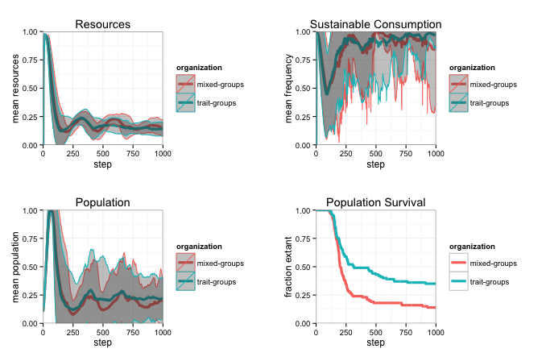

Figure 1. A robustness test reveals that our standard initialization procedure sets the stage for greater population survival than an alternative in which traits are distributed evenly among the individuals of mixed groups. In the plots the central lines represent the mean with 1σ error ribbons from 100 runs of both initialization conditions in the unrestricted treatment.

# Additional Results

## The population of all unrestricted simulations

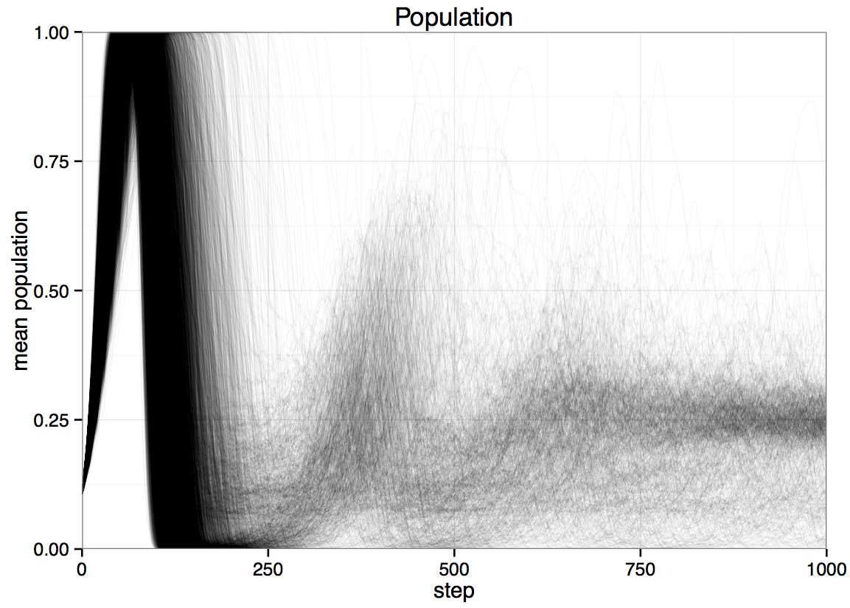

Figure 2. A plot of 1000 simulations of the unrestricted treatment.

## High harvest trait combinations

## Macintosh HD:Users:twaring:Documents:Research:SES Project:Group Selection of SES ABM:Figures:More figures:2B.pdf

Figure 3. Trait combinations which included the unsustainable consumption preference experience early booms and busts but do not persist in the long term. Lines represent the mean with of 1000 runs.

## Group selection statistics

Examining the relationship between the strength of group selection and the cumulative survival probability reveals insights about the evolutionary trajectory of each treatment.

Macintosh HD:Users:twaring:Documents:Research:SES Project:Group Selection of SES ABM:Figures:More figures:magic fig 6 new.pdf

Figure 4. The treatment conditions in which the strength of group selection is correlated with cumulative survival probability are the unrestricted condition and the property condition. Lines represent the mean with of 1000 runs.

## Spatial patterns

Representative spatial configurations from a run of the unrestricted treatment are supplied for reference.

|  |  |  |
| --- | --- | --- |
| A  initialization  Macintosh HD:Users:twaring:Documents:Research:SES Project:Group Selection of SES ABM:Figures:init.png  t=0, groups=9,  population=10% (108) | B  full world  Macintosh HD:Users:twaring:Documents:Research:SES Project:Group Selection of SES ABM:Figures:full.png  t=90, groups=9,  population=100% (1024) | C  post crash  Macintosh HD:Users:twaring:Documents:Research:SES Project:Group Selection of SES ABM:Figures:survivor.png  t=158, groups=1, population=13.5%, low harvest=100%, group property=100%, group production=92%, resources = 11% |
| D  long run    t=1000, groups=1, population=27%, low harvest=100%, private property=100%, group production=63%, resources = 14% | E  very long run  Macintosh HD:Users:twaring:Documents:Research:SES Project:Group Selection of SES ABM:Figures:very long run.pngt=10,000, groups=5, population=28%, low harvest=98.2%, private property=97.3%, no production=72%, group production=28%, resources = 16% |  |

Figure 5. Representative spatial configurations from a run of the unrestricted treatment. Color represents group markers, dots represent individuals with sustainable harvest preferences, squares represent individuals with unsustainable harvest preferences.

# Sensitivity Analyses

We ran one-dimensional sensitivity analyses for all eleven major parameters. These analyses serve the primary purpose of testing to see that our benchmark parameter values are reasonable when compared to results from their possible range, and the secondary purpose of determining what changes in the parameter will result in changes in the likelihood of the emergence of sustainable institutions.

We test each parameter by running 100 simulations to 1000 time steps at each of at least 10 parameter values, and examine four output currencies: resource status, sustainable consumption behavior, population size, and population persistence. We summarize these results at the end of the 1000 step simulations. Each simulation was run in the unrestricted evolution condition with the default parameter set. We plot each output indicator over the selected range of values with 95% confidence intervals except for population survival where they cannot be calculated. The vertical lines represent the default value of the parameter.

The behavioral equilibria we test here are similar to those explored in the paper. Therefore, in most parameters we test, we find that the first three outcome variables (resources, population size, and sustainable consumption) respond less that the population survival. In essence if a parameter influences the emergence of sustainable equilibria, it changes population persistence, but not the nature of those societies that do persist to 1000 steps. We conclude that there are many opportunities to reduce the likelihood of the emergence of sustainable resource consumption and the institutions that support it. However, because we know that people can and do sometimes manage resources sustainably, we focus on the conditions that have allowed that to occur. The sensitivity analysis characterizes the larger parameter space around that explored in the paper.

| **Parameter** | **Description** | **Benchmark** | **Range** |
| --- | --- | --- | --- |
| Intrinsic growth, *r* | Maximum resource growth rate. | 0.5 | [0,1] |
| Cost of sustainable harvest, *Cs* | Proportion of Y* by which high harvest exceeds low. | 1 | [0.1,1.5] |
| Cost of living, *CL* | Proportion of Y* expended for survival every step. | 0.2 | [0,1] |
| Storage limit, *Sl* | Maximum resources an agent can store, applies separately to harvested and processed resources. | 106 | [102,106] |
| Cost of defense, *CD* | Per neighbor cost of defending a patch. | 1 | [0,10] |
| Production contribution, γ | Desired proportion of raw resources an agent contributes to cooperative production. | 0.5 | [0.1,1] |
| Return to production, θ | Growth rate for resources invested in cooperative production. | 1.5 | [1,3] |
| Imitation rate, λ | Per trait probability of imitation. | 0.05 | [0,1] |
| Imitation radius,ρ | Radius within which peer agents are observed for imitation. | 2 | [1,20] |
| Mutation rate, μ | Per trait probability that each trait is randomly selected during reproduction. | 0.003 | [0,0.1] |
| Migration rate, *m* | Probability an agent attempts to move to a neighboring patch with more resources. | 0 | [0,1] |
|  |  |  |  |

Table 1. Benchmark parameter values used in simulation experiments, and parameter ranges tested during sensitivity analysis.

## Intrinsic growth, *r*

The maximum resource growth rate, *r*, is the canonical ecological growth function of a renewable resource. An *r* of 0 represents a non-renewable resource, and *r*=1.0 represents a doubling of the resource every step. If *r* is assumed to be a net yearly biological production of a renewable resource, then reasonable growth rates range from 0.01 to 1.

Macintosh HD:Users:twaring:Documents:Research:SES Project:Group Selection of SES ABM:Analysis-Sensitivity:r.pdf

Figure 6. Model sensitivity to the intrinsic rate of resource growth. Plots of mean output currency at t=1000 with 1σ error ribbons. 100 simulations were run at each tested parameter value in the unrestricted evolution condition, using the default parameter set. Error ribbons for population survival cannot be calculated. Vertical lines represent the default value of the parameter.

Setting r=0 produces 100% responses on all variables. This is caused by a complication resulting in perfect survival rate at r=0. This unrealistic occurs because of various model parameters that are calculated based on maximum sustainable yield, *Y\**. Future research interested in extremely low values of r might decouple those parameters. Here, we tested *r* from 0.3 to 1.0. Resource levels, population size and sustainable consumption were unresponsive to changes in *r*. Unsurprisingly; however, a greater growth rate allows a greater fraction of populations to persist. This occurs because even though many parameters scale with *Y\**, changing *r* does not entail changing K. The benchmark value of *r* falls in the middle of the range of population survival.

## Cost of sustainable harvest, *Cs*

The cost of sustainable harvest, *Cs*, is the proportion of maximum sustainable yield, *Y\**, by which high harvest exceeds low, centered on *Y\**. *Cs* ranges between 0 and 2. When *Cs* = 0.0 there is no difference between high and low harvesting, both types harvest *Y\** exactly. A value of 2.0 corresponds to a low harvest rate of zero and a high harvest rate of 2*Y\**. Both maximum and minimum values are unrealistic, so the default parameter is set at 1. We tested the range between 0.2 and 1.4.

Macintosh HD:Users:twaring:Documents:Research:SES Project:Group Selection of SES ABM:Analysis-Sensitivity:pdfs:gap.pdf

Figure 7. Model sensitivity to the cost of sustainable harvest. Plots of mean output currency at t=1000 with 1σ error ribbons. 100 simulations were run at each tested parameter value in the unrestricted evolution condition, using the default parameter set. Error ribbons for population survival cannot be calculated. Vertical lines represent the default value of the parameter.

The frequency of sustainable consumption was not sensitive to *Cs*. Resource levels and population size at t=1000 both declined from high values at *Cs*=0.2, and then increased above the benchmark value at *Cs*=1.0. Population survival is convex with *Cs*, reaching a maximum at *Cs*=0.8 of ~50% population survival. One explanation for this effect is that at low levels of *Cs* close to *Y\**, the differences between the two harvest levels are small, at intermediate levels of *Cs*, the larger gap effectively makes high harvesters die off more rapidly aiding the emergence of sustainable outcomes, while at the levels above *Cs*=1, low harvests are not sufficient to sustain the agents who practice sustainable consumption.

## Cost of living, *CL*

The cost of living, *CL*, is the proportion of *Y\** an individual expends for survival every step. An *CL* of 0 means that individuals can survive without any environmental consumption, while a value of 1 denotes that the entire maximum sustainable yield of a patch is required to support one individual, every time step. We tested the range between 0 and 1.

Macintosh HD:Users:twaring:Documents:Research:SES Project:Group Selection of SES ABM:Analysis-Sensitivity:costofliving.pdf

Figure 8. Model sensitivity to cost of living. Plots of mean output currency at t=1000 with 1σ error ribbons. 100 simulations were run at each tested parameter value in the unrestricted evolution condition, using the default parameter set. Error ribbons for population survival cannot be calculated. Vertical lines represent the default value of the parameter.

Although we simulated cost of living runs between 0 and 1, above *CL* = 0.5 (cost of living = *Y*/2)* no population survived to 1000 steps, so they are not reflected in the plots below. Interestingly, both the total population survival and the frequency of sustainable consumption were highest at our benchmark value of 0.2, although the peaks are low. These results are not surprising, however, because at a value of 0, survival is free (but consumption still continues), while at a value of 0.5, any occupied patch will be depleted in a only few steps. Thus, a concave function of population survival on cost of living is expected. Overall, an intermediate value of *CL* allows higher population survival, and increasing or decreasing *CL* would cause a reduction in the emergence of sustainable regimes.

## Storage limit, *Sl*

The storage limit, *Sl*, is the total amount of resources an agent can hold of each of harvested and processed types. We varied *Sl* between 0 and 107, while the default value is 106, which allows an agent to have both 106 harvested resources and another 106 processed resource units in storage.

Macintosh HD:Users:twaring:Documents:Research:SES Project:Group Selection of SES ABM:Analysis-Sensitivity:pdfs:storage.pdf

Figure 9. Model sensitivity to the storage limit. Plots of mean output currency at t=1000 with 1σ error ribbons. 100 simulations were run at each tested parameter value in the unrestricted evolution condition, using the default parameter set. Error ribbons for population survival cannot be calculated. Vertical lines represent the default value of the parameter.

The total volume of resource storage has no major impact on resources, population size, or the frequency of sustainable consumption at t=1000, but population survival declines with increasing storage capacity. Somewhat counterintuitively, sustainable populations are less likely to emerge when the individual ability to store resources is greater. This is due to the fact that greater storage levels allow individuals to survive longer without any resource input, and therefore increases the scope for unsustainable consumption. The benchmark value of *Sl*=106 falls within the middle of the population persistence curve.

## Cost of defense, *CD*

The marginal cost of defense, *CD*, is the cost for an agent to prevent neighboring agents from harvesting on the patch they occupy. The total cost of defense each round will vary between 0 and 8*CD*. We varied *CD* between 0 and 10.

Macintosh HD:Users:twaring:Documents:Research:SES Project:Group Selection of SES ABM:Analysis-Sensitivity:pdfs:defense.pdf

Figure 10. Model sensitivity to the cost of defense. Plots of mean output currency at t=1000 with 1σ error ribbons. 100 simulations were run at each tested parameter value in the unrestricted evolution condition, using the default parameter set. Error ribbons for population survival cannot be calculated. Vertical lines represent the default value of the parameter.

As with most parameters, the only outcome metric that varies substantially with the cost of defense is population persistence, which declines with increasing defense costs. This occurs because increases to defending resource productivity damage the total benefits of both group and private property regimes.

## Production contribution, γ

The production contribution, γ, is the amount of harvested (unprocessed) resources an individual will attempt to contribute to cooperative production in the public goods production function. If the agent cannot contribute this amount and still have *CL* left to pay for survival, then the agent pays their entire harvested resources – *CL*, instead. γ can vary between 0 and 1, and the benchmark value is 0.5.

Macintosh HD:Users:twaring:Documents:Research:SES Project:Group Selection of SES ABM:Analysis-Sensitivity:pdfs:gamma.pdf

Figure 11. Model sensitivity to contribution to cooperative economic production. Plots of mean output currency at t=1000 with 1σ error ribbons. 100 simulations were run at each tested parameter value in the unrestricted evolution condition, using the default parameter set. Error ribbons for population survival cannot be calculated. Vertical lines represent the default value of the parameter.

Population survival increases with the sharing proportion, but other indicators do not vary much by sharing proportion.

## Return to production, θ

The return to production, θ, is the return on investment in the dyadic public good interaction. We varied θ at intervals of 0.1 between 1.0 and 3.0. A θ of 1.0 represents zero return on resources invested, a value of 2.0 represents a doubling of the investment. The range of 1.0-2.0 is reasonable range of resource productivity values. We also included simulations all the way to θ=3.0, which represents a tripling of invested resources.

Macintosh HD:Users:twaring:Documents:Research:SES Project:Group Selection of SES ABM:Analysis-Sensitivity:theta.pdf

Figure 12. Model sensitivity to the return to economic production. Plots of mean output currency at t=1000 with 1σ error ribbons. 100 simulations were run at each tested parameter value in the unrestricted evolution condition, using the default parameter set. Error ribbons for population survival cannot be calculated. Vertical lines represent the default value of the parameter.

Resources, population size, and sustainable consumption do not vary dramatically with θ. Resources and sustainable consumption display almost no change over the tested parameter range, and long term population size only increases from ~20% to 30% of K. Population survival increases with θ, ranging between 15% (at θ =1) to 65% (at θ =3). Our selected value, (θ =1.5) rests in the middle of this distribution.

## Imitation rate, λ

The rate of imitation, λ, is the probability that an agent will attempt to imitate a more wealthy agent within the imitation radius, ρ, per step. The imitation rate can vary naturally between 0 and 1, and the benchmark value is 0.05, and we tested the values between 0 and 0.1. The value of λ=0.1 corresponds to attempting to imitate 10% of the time.

Macintosh HD:Users:twaring:Documents:Research:SES Project:Group Selection of SES ABM:Analysis-Sensitivity:pdfs:lambda.pdf

Figure 13. Model sensitivity to the imitation rate. Plots of mean output currency at t=1000 with 1σ error ribbons. 100 simulations were run at each tested parameter value in the unrestricted evolution condition, using the default parameter set. Error ribbons for population survival cannot be calculated. Vertical lines represent the default value of the parameter.

Populations survive with greater frequency as λ decreases, but the other parameters are largely unchanged over the tested range. We expect that increasing λ to 1.0 would cause a continued decline in population survival, as it would facilitate the spread of unsustainable consumption preferences that are associated with greater wealth, because the resource wealth is the cue agents use to imitate.

## Imitation radius, ρ

The imitation radius, ρ, is the straight-line distance from the center of a focal agents patch to the other patches within which a patch must fall for an agent occupying that patch to be included in the population of agents that the focal agent will imitate from. This radius can vary between 0 and 24. At ρ=24, all agents can sample agents to imitate from the entire simulated world. The benchmark value of ρ = 2, which includes the agents resource commons and the next four closest patches for a total of 12 patches. The model uses payoff biased imitation, so that we should expect unsustainable consumption preferences to increase with ρ.Macintosh HD:Users:twaring:Documents:Research:SES Project:Group Selection of SES ABM:Analysis-Sensitivity:pdfs:rho.pdf

Figure 14. Model sensitivity to the imitation radius. Plots of mean output currency at t=1000 with 1σ error ribbons. 100 simulations were run at each tested parameter value in the unrestricted evolution condition, using the default parameter set. Error ribbons for population survival cannot be calculated. Vertical lines represent the default value of the parameter.

As expected, as the radius of imitation increases, resources, population size and population survival all decline. Counterintuitively, we observe a U-shaped relationship of sustainable consumption on ρ. The increase in sustainable consumption beyond ρ=12 should be taken lightly because almost no populations survive under such global imitation conditions. The benchmark value of ρ=2 creates a regime of local imitation, which suggests that local imitation is key to the group selection of sustainable resource management institutions.

## Mutation rate, μ

The mutation rate, μ, is the independent rate at which each trait is mutated during reproduction. Mutation does not occur during the rest of the agent life span, while imitation does. Mutation can vary between 0 and 1, but because genetic mutation rates are low and vertical cultural transmission is more conservative, we set the benchmark mutation rate to 0.003, and tested values between μ=0 and μ=0.1.

Macintosh HD:Users:twaring:Documents:Research:SES Project:Group Selection of SES ABM:Analysis-Sensitivity:mu.pdf

Figure 15. Model sensitivity to the mutation rate. Plots of mean output currency at t=1000 with 1σ error ribbons. 100 simulations were run at each tested parameter value in the unrestricted evolution condition, using the default parameter set. Error ribbons for population survival cannot be calculated. Vertical lines represent the default value of the parameter.

When μ=0, resources, population size and population survival all reach nearly 100%, but above that number the outcome variables decline as mutation creates a never-ending stream of resource free-riders.

## Migration rate, *m*

The migration rate, *m*, is the rate at which individuals attempt to move within their local resource commons. This rate can vary between 0 and 1, and the benchmark value is 0. Sensitivity analysis shows that varying migration has no effect on any outcome parameter.

Macintosh HD:Users:twaring:Documents:Research:SES Project:Group Selection of SES ABM:Analysis-Sensitivity:pdfs:migrate.pdf

Figure 16. Model sensitivity to the migration rate. Plots of mean output currency at t=1000 with 1σ error ribbons. 100 simulations were run at each tested parameter value in the unrestricted evolution condition, using the default parameter set. Error ribbons for population survival cannot be calculated. Vertical lines represent the default value of the parameter.

# ODD Protocol Format

## Purpose

This model was constructed for the purpose of exploring the conditions under which sustainable management of a renewable and exhaustible natural resource is able to emerge within a simple society characterized by the potential for collaborative production for surplus and rudimentary group structure and mechanisms. Specifically, the model aims to simulate the emergence of key social and economic norms, including the first of Ostrom’s design principles (resource use boundaries), and commonly found in successful resource management institutions. The model allows social groups and economic regimes to emerge endogenously, and proliferate when successful, and fail due to resource collapse. This evolutionary approach allows us to uncover those factors, which increase the frequency of the emergence of sustainable resource management.

## Entities, state variables, and scales

Entities in the model include agents (individuals) and spatial units (patches of land). Although social groups exist, they do not act collectively, rather the agents’ behavior is at times contingent upon group affiliations.

## Agents

The agents in the model have four primary traits that govern behavior; a group maker, a harvesting preference, a property norm, and a production norm. Agents also have an identity number and a spatial location defined as the patch upon which they are standing. Agents are also characterized by their age, their lifetime reproductive success. Three resource variables are associated with agents; total resources harvested within a time step, as well as two stored-resource totals for unprocessed and processed resources. Table 1 lists the state variables and provides a brief description of each.

|  |  |  |
| --- | --- | --- |
| **Agent Variable** | **Description** | **Range** |
| Group marker, *gi* | Marker that identifies agent as a member of a given social group | [1,9] |
| Sharing trait, *si* | Ternary trait determining agent’s behavior in a pairwise sharing encounter: share with no one (N), group members (G), or all individuals (A) | A,N,G |
| Harvesting trait, *hi* | Binary trait (*high harvesters* and *low harvesters*) determining maximum raw resources an agent attempts to harvest from its available land | H,L |
| Property norm, *pi* | Ternary trait determining which neighboring agents an agent will defend its property (and, specifically, its harvestable resources) against: defend against no one (N), out-group members (O), or all individuals (A) | A,N,O |
| Agent identity, *whoi* | Identifier associated with the agent | positive integer |
| Agent location, *patch_ati* | Location associated with the agent as defined by the patch the agent is currently standing on | integer pair |
| Agent age, *agei* | Number of simulation time steps the agent has survived | positive integer |
| Harvested amount, *Hi* | Running total of the amount of resource that has been harvested at a given time step | positive integer |
| Raw resources, *ri* | Accumulated resources harvested from the land | positive integer |
| Processed resources, *pi* | Accumulated resources produced by contributing raw resources to a cooperative process (modeled as a two-person public goods game) | positive integer |
| Reproductive success, *rsi* | Running total of the number of offspring of an agent within its lifespan | positive integer |

## Patches

These entities have only two attributes, patch resources and patch regrowth rate. These are listed in Table 2 below along with their descriptions.

|  |  |  |
| --- | --- | --- |
| **Patch Variable** | **Description** | **Range** |
| Patch resources, *cropj* | Amount of resource currently growing upon the patch | positive integer |
| Patch regrowth, *prj* | Local patch maximum intrinsic rate of growth | positive integer |

## Environment

## The model has no externally varying environmental conditions.

## Collectives

## Although agents have a group identity, this group does not act as a collective. No joint decisions are made, and although social identity is shared, all actions are individual.

## Spatial and Temporal Scales

## Each grid cell or patch represents a plot of land large enough to feed a person or family. The model is a 32 x 32 torus. Each time step represents approximately one year.

## Process overview and scheduling

The following provides a general version of the process overview and scheduling. For more detail regarding each of the procedures, please see the *submodels* section or the model code. At initialization, agents, patches and global variables are set up. The following process repeats every time step.

* *Patch defense*: Agents pay a cost to defend their focal patch.
* *Harvesting*: Agents harvest resources from their focal and neighboring patches.
* *Sharing*: Agents have the opportunity to produce processed resources with a neighbor.
* *Pay cost of living*: Agents lose resources in order to stay alive.
* *Death*: Agents die if their resources drop below zero or due to a random events, the probability of which increases with age.
* *Reproduction*: Agents with sufficient resources attempt to reproduce.
* *Migration*: Agents move to an empty neighboring patch.
* *Imitation*: Agents may imitate the traits of others with certain biases.
* *Patch growth*: Patch resources increase if they are below maximum.
* *Aging*: Agents grow older.
* *Cap resources*: Agents resources above a threshold are eliminated.

## Design concepts

## Basic principles

This model places a spatially-explicit ABM of the evolution of cooperation within the context of a social-ecological system. It draws upon theory regarding cooperation, commons dilemmas, group selection, and Ostrom’s design principles.

## Emergence

Spatially coherent social groups of like agents emerge endogenously. Groups that persist sometimes consist of parochial and cooperative agents who harvest at low levels.

## Adaptation

Agents adapt at genetically and culturally. Agents have a simple 4 locus ‘behaviorome’ [harvest, group, property, production]. In the genetic portion, mutation of all these traits occurs with a given probability at reproduction. Death and differential reproduction then create selection and adaptation on these loci over time. In the cultural portion, agents adapt every round through a process of payoff-biased imitation.

## Objective

Agents have a harvest preference that they attempt to satisfy. Beyond that, agents do not have internalized goal states, or encoded objectives.

## Learning

There is no learning in this model.

## Prediction

There is no prediction in this model.

## Sensing

Agents observe the group markers, wealth, and traits of the other agents in their Moore neighborhood and within the imitation radius of their patch. Agents observe these variables perfectly, but only do during the model routine. Agents are also able to sense the amount of resource on their current patch as well as the amount of resource on neighboring patches.

## Interaction

Agents interact with patches by harvesting resources. Agents both compete and cooperate. Agents interact with other agents through defense of their patch, engagement in cooperative production, reproduction and imitation.

## Stochasticity

There is stochasticity in the initialization of patch resources, in the placement of the initial agents, in the assignment of traits to agents, in migration, imitation, and mutation of offspring traits, and in all probabilistic procedures.

## Collectives

Each agent interaction for the purposes of economic production can be seen as a brief collective in that the payoff received from the public goods game is dependent upon the participation of both actors and is split between the two parties. The collective then splits at the end of the round. Alternatively socially marked groups can be seen as collectives, with common social marking, and sometimes common production or harvesting traits. However, these collectives do not perform collective behaviors *per se*.

*Observation*

We collected population size, frequency of low harvest norm, frequencies of each production norm, frequencies of each property norm, number of groups, mean individual conservation-fitness covariance, and group conservation-fitness covariance by timestep. Agents do not observe or sample the world.

## 5. Initialization

## The model world is initialized with nine groups of 12 agents each. Groups are located randomly on the 32x32 patch grid. All individuals begin the simulations with the conservative harvesting trait.

## The following global parameters, listed below in Table 3, are set at model initialization. The values at which they are set within the model are detailed in section eight, Simulation experiments/model analysis.

**Table 3. Global parameters**

| **Parameter** | **Description** | **Benchmark** | **Range** |
| --- | --- | --- | --- |
| Lattice size, *L* | Width and length of the square lattice. | 32 x 32 | na |
| Refuge size, *Fs* | Resource refuge level. | 3 | na |
| Refuge probability, *Fp* | Probability a depleted patch will regrow. | 0.001 | na |
| Initial groups, *Gni* | Initial number of groups. | 9 | na |
| Initial group size, *Gsi* | Initial number of individuals in each group. | 12 | na |
| Carrying capacity, *K* | Maximum resources a patch can contain. | 200 | na |
| Intrinsic growth, *r* | Maximum resource growth rate. | 0.5 | [0,1] |
| Cost of sustainable harvest, *Cs* | Proportion of Y* by which high harvest exceeds low. | 1 | [0,2] |
| Cost of living, *CL* | Proportion of Y* expended for survival every step. | 0.2 | [0,1] |
| Storage limit, *Sl* | Maximum resources an agent can store, applies separately to harvested and processed resources. | 106 | [102,106] |
| Cost of defense, *CD* | Per neighbor cost of defending a patch. | 1 | [0,10] |
| Production contribution, γ | Desired proportion of raw resources an agent contributes to production. | 0.5 | [0.1,1] |
| Return to production, θ | Growth rate for resources invested in production. | 1.5 | [1,3] |
| Imitation rate, λ | Per trait probability of imitation. | 0.05 | [0,1] |
| Imitation radius,ρ | Radius within which peer agents are observed for imitation. | 2 | [1,20] |
| Mutation rate, μ | Per trait probability that each trait is randomly selected during reproduction. | 0.003 | [0,0.1] |
| Migration rate, *m* | Probability an agent attempts to move to a neighboring patch with more resources. | 0 | [0,0.1] |
|  |  |  |  |

## Input data

This theoretical model does not require any input data.

## Submodels

Beyond model procedures, no submodels exist in this model. See the model description for an overview of the procedures, and the model code for the procedures themselves.